**Computer Organization & Assembly Language**

**Lab 12**

**Topics:**

See the following on Irvine library [documentation](https://csc.csudh.edu/mmccullough/asm/help/)

1. SetTextColor
2. Gotoxy
3. GetTextColor
4. Delay
5. GetMaxXY
6. ClrScr
7. WaitMsg

**Color Attributes:**

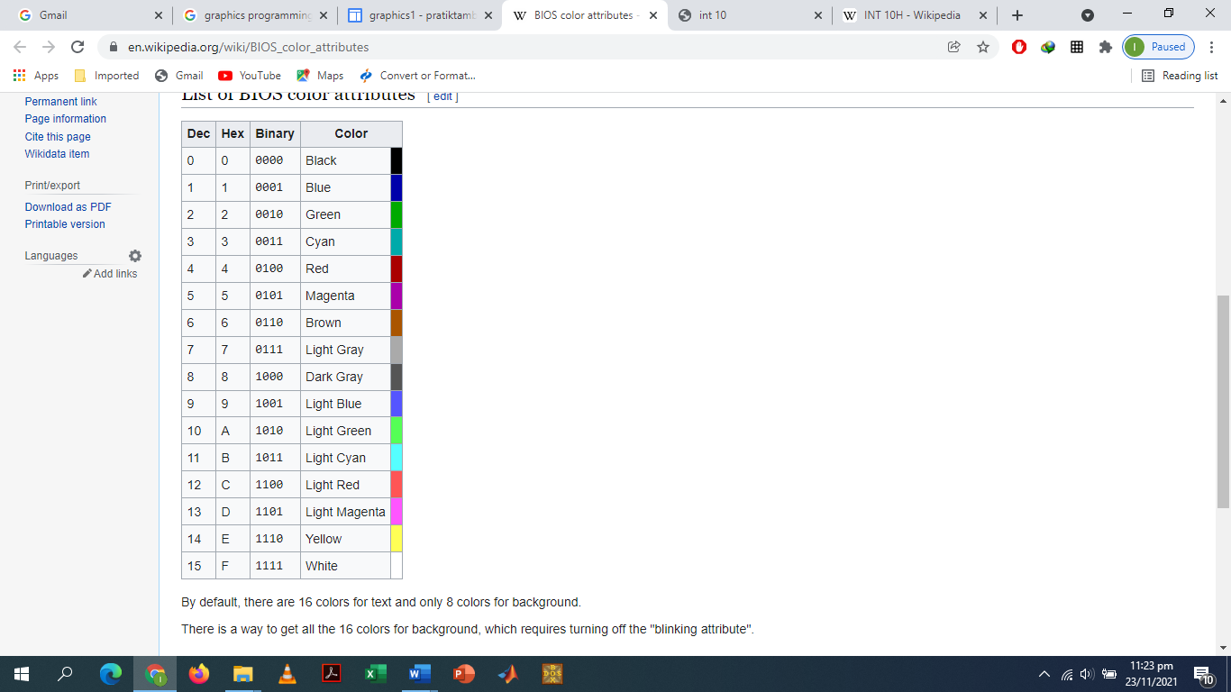

**Tasks:**

* Write an assembly program that takes the coordinates of start as in input from user and display star at that coordinate.
* Now building on the above program, take foreground (text color) and background color of start as input from user and color it. Display a color pallet to user for input colors. (Eg Press ‘1’ for red, Press ‘2’ for yellow etc).
* Write an assembly program that takes coordinates and colors from user as an input and write text on that coordinates.
* Write an assembly program to create a filled rectangle
  1. Take input the length and width of rectangle from user
  2. Take input of border color from user
  3. Take input of filled color (inside of rectangle from user)
  4. Take input the coordinates where the rectangle will be drawn from user
* Write an assembly program to make a snake game without terminating condition. (Modify the already provided code).

**Submission Instructions:**

* Write your name, roll no and section on top of your code file
* Do all of your code work in procedures and just call that procedure in main to execute the code. You will make 7 different procedures for each question.

Eg:

Q1 proc

;code

ret

Q1 endP

* **Self-Evaluation: (bonus 2 marks)**

You are to self-evaluate all the questions you do. Write a one-liner comment for each question on top of code file below your name.

Eg. Q1, all done, works completely fine for all use cases

Q2, partially done, exception thrown error

You must be honest in self-evaluating yourself.

**If during evaluation you are found being dishonest, your lab will be marked zero.**

* Submit only one .asm file (Format: i22-1234_LAB12.asm